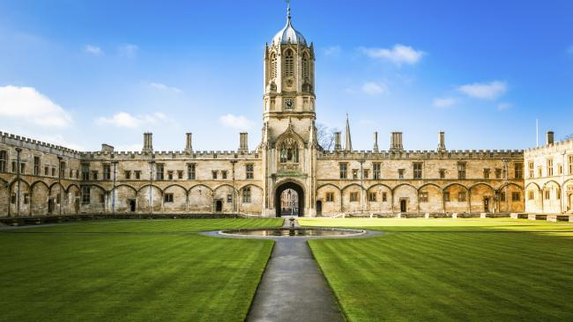

#### PROJECT

#### University Information System

**Name:**RiteshTiwari

**Roll No:** P03201818c

**Course:** CCPA

**Project Name:** University Information System In Wordpress with php

**Software use**

Microsoft Expression Web4 , Wamp server , Google Crome ,Notepad , Windows 10

**Hardware use**

Mouse , Keypad , printer , CD;

Index.html

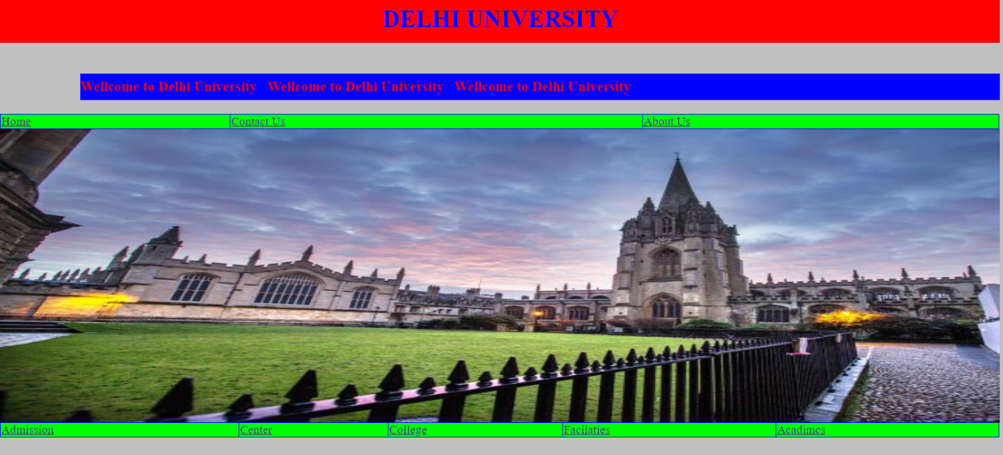

<html>

<head>

<title>Delhi University</title>

<link rel="stylesheet" href="style.css">

</head>

<body>

<h1><center> DELHI UNIVERSITY</center></h1>

<marquee direction="left"><h3>Wellcome to Delhi University &nbspWellcome to Delhi University &nbspWellcome to Delhi University</h3></marquee>

<table width="100%">

<trbgcolor="lime" >

<td><a href="index.html">Home</a></td>

<td><a href="contac_us.php">Contact Us </a></td>

<td><a href="about_us.php"> About Us</a></td>

</tr>

</table>

<imgsrc="Winter Solstice14831x.jpg.gallery.jpg" width="100%" height="60%">

<table width="100%">

<trbgcolor="lime" >

<td><a href="addmission.html">Admission</a></td>

<td><a href="center.php">Center </a></td>

<td><a href="college.php">College</a></td>

<td><a href="facilaties.php">Facilaties</a></td>

<td><a href="acadimcs.php">Acadimcs</a></td>

</tr>

</table>

</body>

</html>

**Style.css:-**

body{

background:silver;

color;red;

}

h1{

background: red;

color:blue;

padding:10px 0px 20px 0px;

}

h3{

background: blue;

color:red;

padding:10px 0px 10px 0px;

}

**Contac us.php:-**



<html>

<head>

<title> Contac Us</title>

</head>

<body bgcolor="silver" >

<h1><a href="index.html">Home</a></h1>

<?php

echo"<h1><center>Contac us</h1></center><hr>";

echo"Vice Chancellor :Vc@du.ac.in<br>";

echo"Pro-Vice Chancellor:pvc@du.ac.in<br>";

echo"Dean of Collegeas :dean_college@du.ac.in <br>";

echo"Director , South Campus :dir_udsc@du.ac.in<br>";

echo"Registar :registar@du.ac.in<br>";

echo"Controller of Exam: Fax No-91-11-27667336<br>";

?>

</body>

</html>

**About us.php:-**

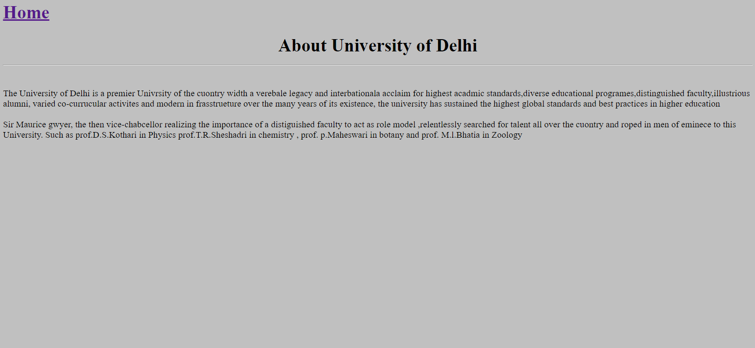

<html>

<head>

<title>About us</title>

</head>

<body bgcolor="silver" font-size="20" >

<h1><a href="index.html">Home</a></h1>

<?php

echo"<h1><center>About University of Delhi</center><hr></h1><br>";

echo"The University of Delhi is a premier Univrsity of the cuontry width a verebale legacy and interbationala acclaim for highest acadmicstandards,diverse educational programes,distinguishedfaculty,illustrious alumni, varied co-currucularactivites and modern in frasstrueture over the many years of its existence, the university has sustained the highest global standards and best practices in higher education <br><br>";

echo"\nSir Maurice gwyer, the then vice-chabcellor realizing the importance of a distiguished faculty to act as role model ,relentlessly searched for talent all over the cuontry and roped in men of eminece to this University. Such as prof.D.S.Kothari in Physics prof.T.R.Sheshadri in chemistry , prof. p.Maheswari in botany and prof. M.l.Bhatia in Zoology";

?>

</body>

</html>

**Admission.html:-**

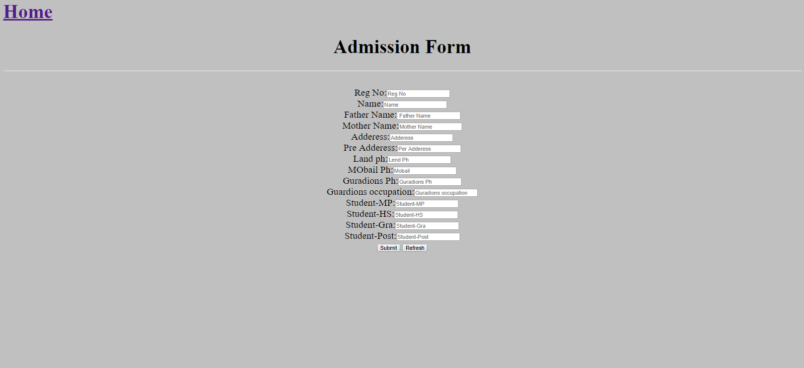

<html>

<head>

<title>Addmission</title>

</head>

<body bgcolor="silver">

<form name="frm">

<h1><a href="index.html">Home</a></h1>

<h1><center>Admission Form</center></h1><hr>

<br>

RegNo:<input type="text" placeholder="Reg No" name="var1"><br>

Name:<input type="text" placeholder="Name" name="var2"><br>

Father Name:<input type="text" placeholder=" Father Name" name="var3"><br>

Mother Name:<input type="text" placeholder="Mother Name" name="var4"><br>

Adderess:<input type="text" placeholder="Adderess" name="var5"><br>

Pre Adderess:<input type="text" placeholder="Per Adderess" name="var6"><br>

Land ph:<input type="text" placeholder="Lend Ph" name="var7"><br>

MObailPh:<input type="text" placeholder="Mobail" name="var8"><br>

GuradionsPh:<input type="text" placeholder="GuradionsPh" name="var9"><br>

Guardionsoccupation:<input type="text" placeholder="Guradions occupation" name="var10"><br>

Qualification:<input type="checkbox" name="quali">Madhayamik

<input type="Checkbox" name="quali">H.S

<input type="Checkbox" name="quali">Gra

<input type="Checkbox" name="quali">Post<br>

<input type="submit" name="submit" value="Submit">

<input type="reset" name="reset" value="Refresh">

</form>

</body>

</html>

**Centers.php:-**

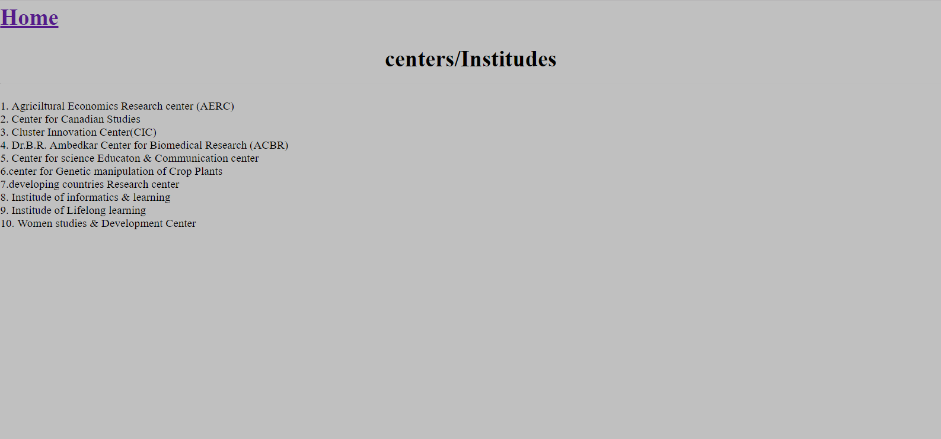

<html>

<head>

<title>Center</title>

</head>

<body bgcolor="silver">

<h1><a href="index.html">Home</a></h1>

<?php

echo"<h1><center>centers/Institudes</center><hr></h1>";

echo"1. Agriciltural Economics Research center (AERC)<br>";

echo"2. Center for Canadian Studies<br>";

echo"3. Cluster Innovation Center(CIC) <br>";

echo"4. Dr.B.R. Ambedkar Center for Biomedical Research (ACBR)<br>";

echo"5. Center for science Educaton& Communication center<br>";

echo"6.center for Genetic manipulation of Crop Plants<br>";

echo"7.developing countries Research center<br>";

echo"8. Institude of informatics & learning<br>";

echo"9. Institude of Lifelong learning<br>";

echo"10. Women studies & Development Center <br>";

?>

</body></html>

**College.php:-**

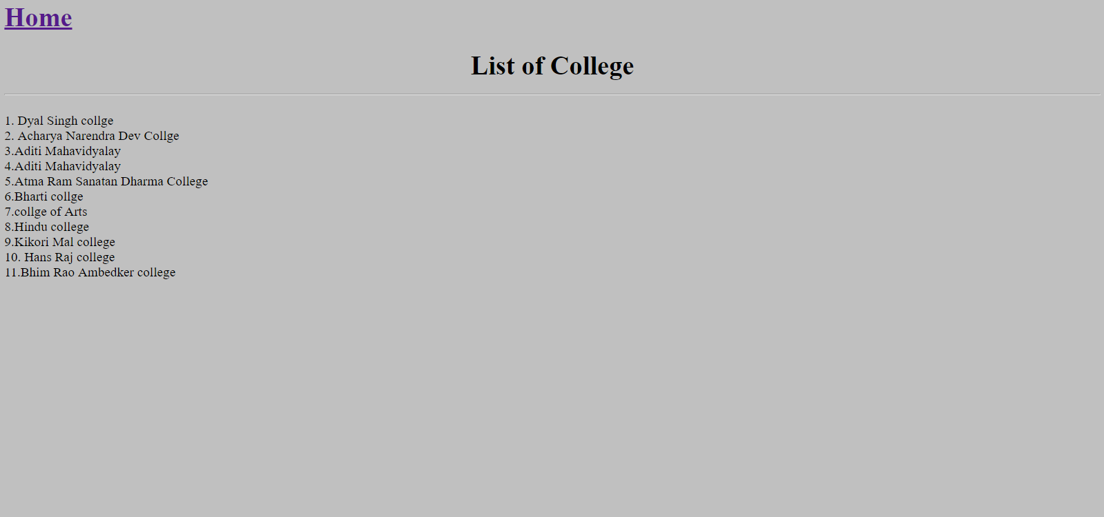

<html>

<head>

<title>college</title>

</head>

<body bgcolor="silver">

<h1><a href="index.html">Home</a></h1>

<?php

echo"<h1><center>List of College</center><hr></h1>";

echo"1. Dyal Singh collge<br>";

echo"2. AcharyaNarendraDevCollge<br>";

echo"3.Aditi Mahavidyalay<br>";

echo"4.Aditi Mahavidyalay<br>";

echo"5.Atma Ram Sanatan Dharma College<br>";

echo"6.Bharti collge<br>";

echo"7.collge of Arts<br>";

echo"8.Hindu college<br>";

echo"9.Kikori Mal college<br>";

echo"10. Hans Raj college<br>";

echo"11.Bhim RaoAmbedker college";

?>

</body></html>

**FACILATIES.php:-**

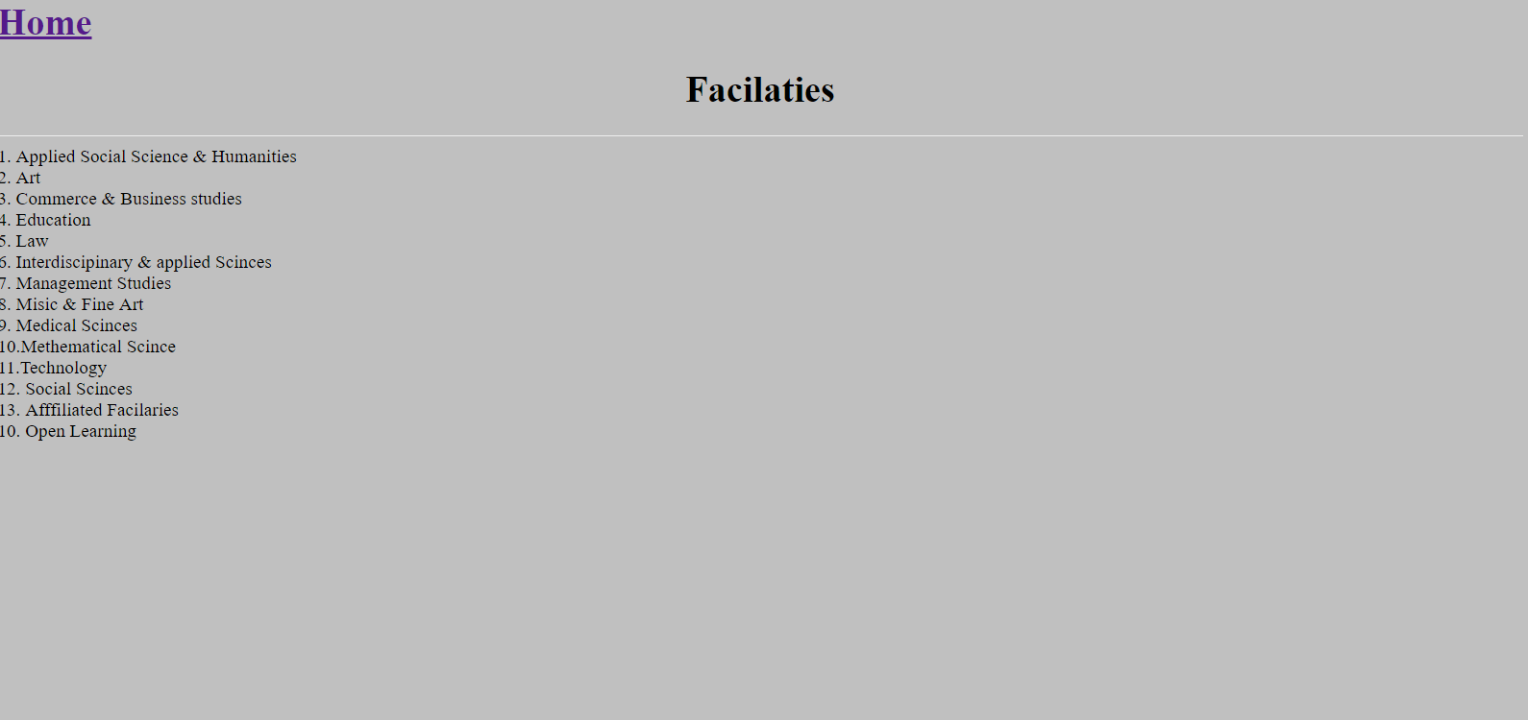

<html>

<head>

<title>Facilaties</title>

</head>

<body bgcolor="silver">

<h1><a href="index.html">Home</a></h1>

<?php

echo"<h1><center>Facilaties</center></h1><hr>";

echo"1. Applied Social Science & Humanities<br>";

echo"2. Art<br>";

echo"3. Commerce & Business studies<br>";

echo"4. Education<br>";

echo"5. Law<br>";

echo"6. Interdiscipinary& applied Scinces<br>";

echo"7. Management Studies<br>";

echo"8. Misic& Fine Art<br>";

echo"9. Medical Scinces<br>";

echo"10.Methematical Scince<br>";

echo"11.Technology <br>";

echo"12. Social Scinces<br>";

echo"13. AfffiliatedFacilaries<br>";

echo"10. Open Learning<br>";

?>

</body>

</html>

**ACADIMCS.php:-**

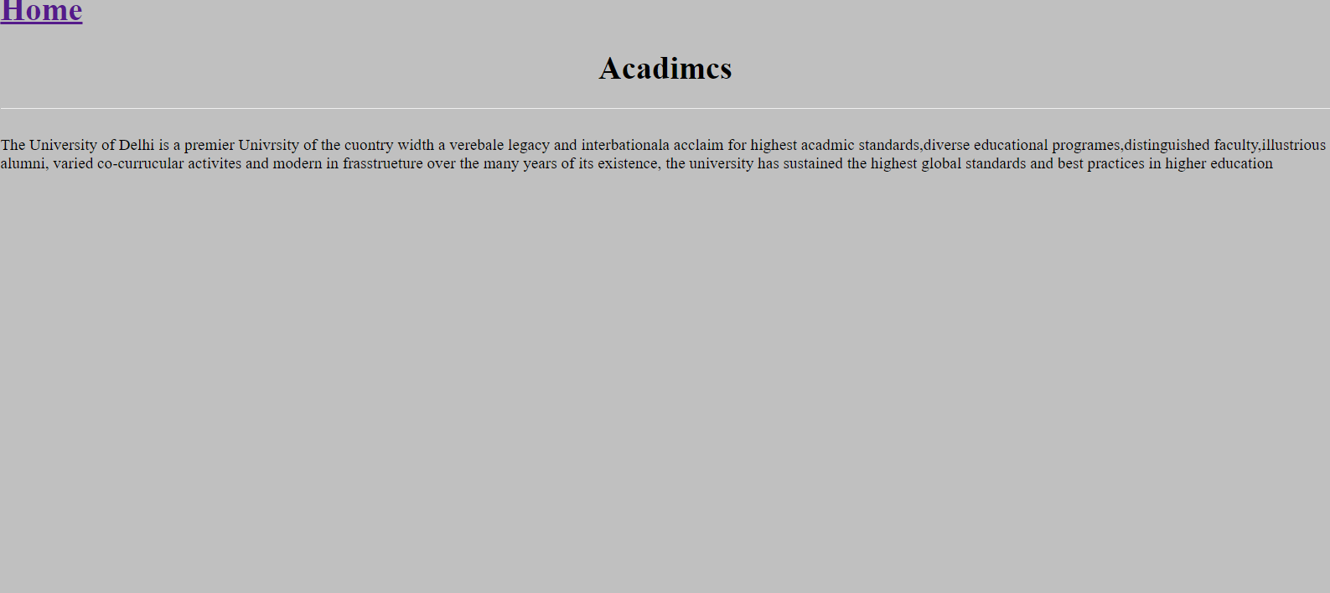

<html>

<head>

<title>Acadimcs</title>

</head>

<body bgcolor="silver" >

<h1><a href="index.html">Home</a></h1>

<?php

echo"<h1><center>Acadimcs</center></h1><hr><br>";

echo"The University of Delhi is a premier Univrsity of the cuontry width a verebale legacy and interbationala acclaim for highest acadmicstandards,diverse educational programes,distinguishedfaculty,illustrious alumni, varied co-currucularactivites and modern in frasstrueture over the many years of its existence, the university has sustained the highest global standards and best practices in higher education <br><br>";

?>

</body>

</html>